**Reliability Workbook**

This workbook focusses on the Reliability pillar of the Azure Well-Architected Framework and provides insights into the reliability aspects deployed in Azure subscriptions.

User needs to import the Azure Monitor workbook available in this repository, the detailed instructions have been provided under [Import Workbook](https://github.com/Kaspanitz/reliability/blob/dev/import.md) section.

User needs to have at least [Workbook Contributor](https://docs.microsoft.com/en-us/azure/role-based-access-control/built-in-roles#workbook-contributor) access to import the workbook and [Monitoring Reader](https://docs.microsoft.com/en-us/azure/role-based-access-control/built-in-roles#monitoring-reader) to have access to monitoring information.

**Note**

* Azure Security Center with Azure Defender is required for VM backup information.
* VMs have to be running for disk information to be available.

**Import Workbook**

There are two ways to import the workbook. First and easy way is to leverage “Deploy to Azure” feature available on this repository. The second alternate approach is to manually import the workbook Json object into the new workbook template.

**Option 1: Deploy directly from GitHub**

1. Navigate to the root of the repository and spot the “Deploy to Azure” option and click to start the deployment

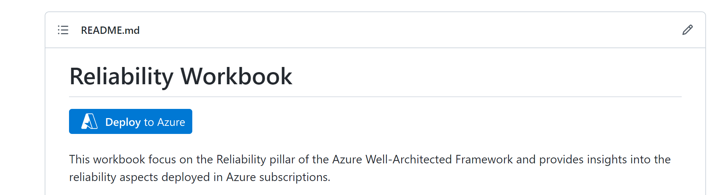

1. This will initiate a custom ARM deployment in Azure portal where we can customize deployment options like Subscription, Resource Group, Region and Display Name of the workbook. The Workbook Id field can be left unchanged so that it can autogenerate new GUID.
2. Review and submit the deployment. This will create the workbook under the chosen subscription and resource group. Navigate to Azure monitor workbook section or directly to the resource group to open new workbook. Pick right environment “Azure” for public cloud and “Azure Government” for Government cloud customers

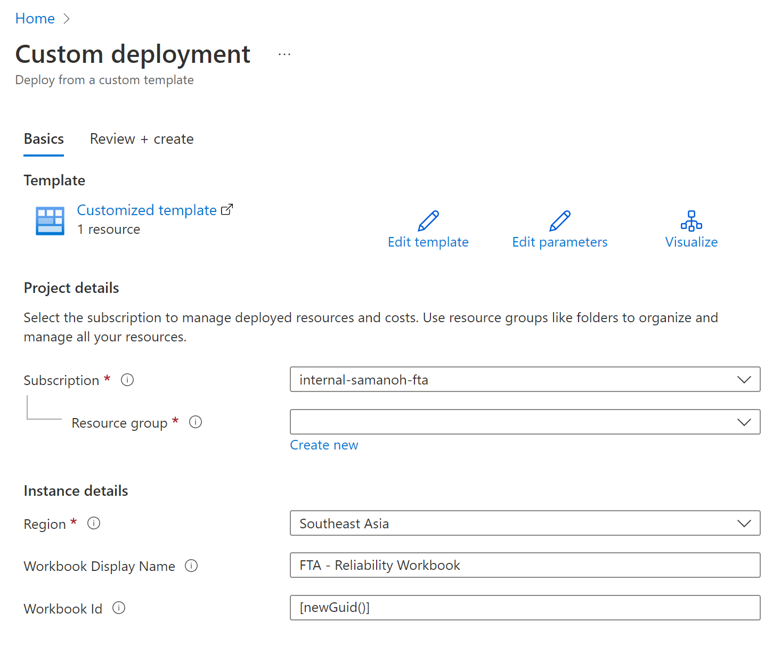

**Option 2: Manually import Workbook Json file**

1. Navigate to Monitor in the Azure Portal and workbooks section
2. Click “New” to create new blank workbook

1. Choose Advanced Editor (</>) to edit the workbook.

1. Paste json from “workbooks/ReliabilityWorkbook.json” into Gallery Template.

1. Click Apply to load the workbook from the gallery template.
2. Click "Done Editing" and click "Save" icon to save the workbook
3. Pick the right cloud environment - "Azure" for public cloud and "Azure Government" for Government cloud tenants

**Report Exports**

**NOTE:** Select the right filters for “Cloud”, “Subscriptions”, “Resource Groups”, “Environment” and “Tag Name/Tag Value” to pick the right scope for this Reliability Engagement.

1. **Summary by Resource Type, Environment and Resource**

Navigate to “Export” tab of the report and click the download button highlighted below for “Summary by Resource Type and Environment” table.

Rename the downloaded report to “Summary by Resource Type, Environment and Resource.xlsx”

1. **Resources Details**

Navigate to “Export” tab of the report and click the download button highlighted below for “Resources Details” table.



Rename the downloaded report to “Resources Details.xlsx”

1. **Advisor – Reliability**

Navigate to “Export” tab of the report and click the download button highlighted below for “Advisor Recommendations by Impact” table.

Rename the downloaded report to “Advisor - Reliability.xlsx”

1. **Workbook Reliability Score**

Navigate to summary page and capture the single “Workbook reliability score” by choosing the right filters. Example below:

